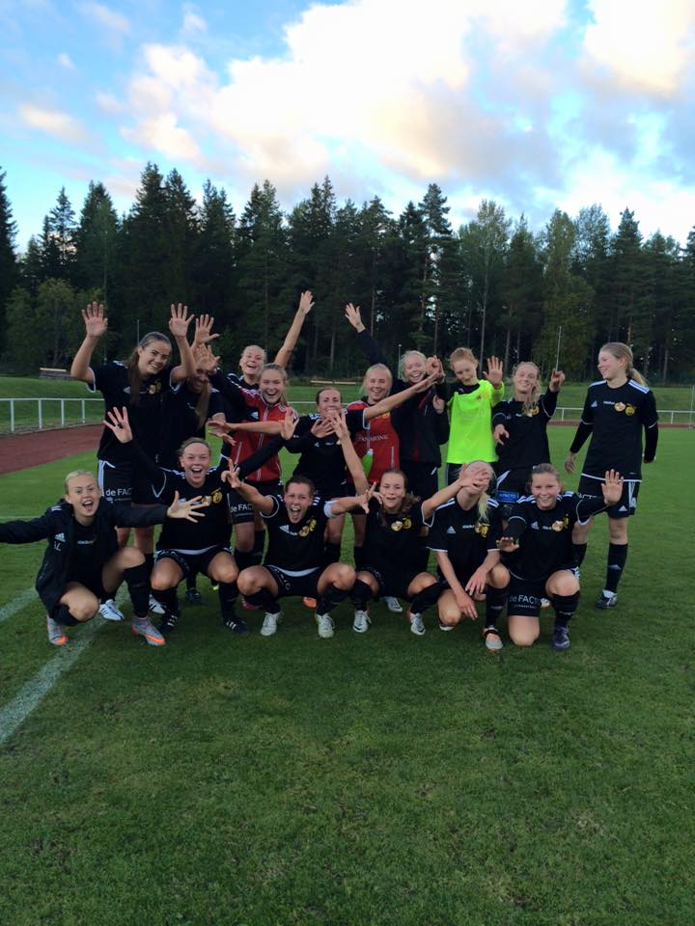

"Surround yourself with good people, surround yourself with positivity and people who are going to challenge you to make you better.
If you just kind of let yourself stay alone and be by yourself, the negative, it is just not going to help you. You can control two things, your work ethic and your attitude about anything."
— Ali Krieger

